
Unit 11: Practice & Assessments
Lesson 1: Core Manufacturing Skills – Review Lesson

Student

Booklet

Practice & Assessments

Acknowledgements
Aerospace Joint Apprenticeship Committee (AJAC), American Society of Metals (ASM), The Boeing Company, National STEM Consortium (NSC), Skills Inc., Washington Manufacturing Advanced Training Institute (WMATI).
About These Materials
Copyright
© 2015 by Washington Manufacturing Advanced Training Institute (WMATI)
The CorePlus: Manufacturing Skills Curriculum is a collaboration among Boeing and WMATI
License
Unless otherwise specified, this work is licensed under a Creative Commons Attribution-ShareAlike 4.0 International License.

Attribution
To attribute this course reference Washington Manufacturing Advanced Training Institute (WMATI).
Citation
To cite this course use the following citation example:
Washington Manufacturing Advanced Training Institute (WMATI). CorePlus Manufacturing Skills Curriculum: Precision Measurement Course. [URL if applicable.] CorePlus, 2015.

Disclaimer
This workforce solution was built from open license materials from many sources. There are no guarantees, warrantees, or assurances of any kind, express or implied, with respect to such information, including any information on linked sites and including, but not limited to, accuracy of the information or its completeness, timeliness, usefulness, adequacy, continued availability, or ownership.

Table of Contents
Core Manufacturing Skills - Review Lesson 3
Tool Identification Review 3
Review of manufacturing skills processes 6
Drilling 7
Countersinking 9
Basic Riveting & Rivet Removal 9
Flush Riveting 9
Aerospace Riveting 10
Lock Bolt and Hi-Lok Installation 10
Installation of Torqued Nut & Bolt Fasteners 10
Fastener Removal 11
Removal of Hex Drive Fasteners & Lock Bolts 11
conclusion 12

Core Manufacturing Skills - Review Lesson
To enter a career in aviation manufacturing, you must show competency in the basic core manufacturing skills used by entry-level aircraft assemblers. All the knowledge and skills you’ve learned in the CorePlus curriculum is valuable, but the basic skills of drilling, countersinking, deburring, and fastener installation are critical.

One of the first things that any employer will do is test you in these skills. Being familiar with the skills is not enough. Showing competency is a minimum expectation. But expertise in these skills is what your future employer will really want to see.

This unit will provide opportunities to further practice your core manufacturing skills that you originally learned during the first year units of CorePlus.

This is the first of three instructor-led lessons in this unit. The purpose of the unit is to review, practice and assess student ability in the core manufacturing skills.

Tool Identification Review
Tool Identification: Pistol Grip Drill Motor
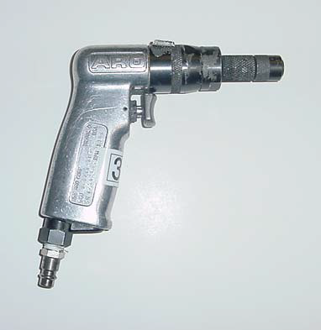
Image courtesy of The Boeing Company

Tool Identification: 90 Degree Drill Motor
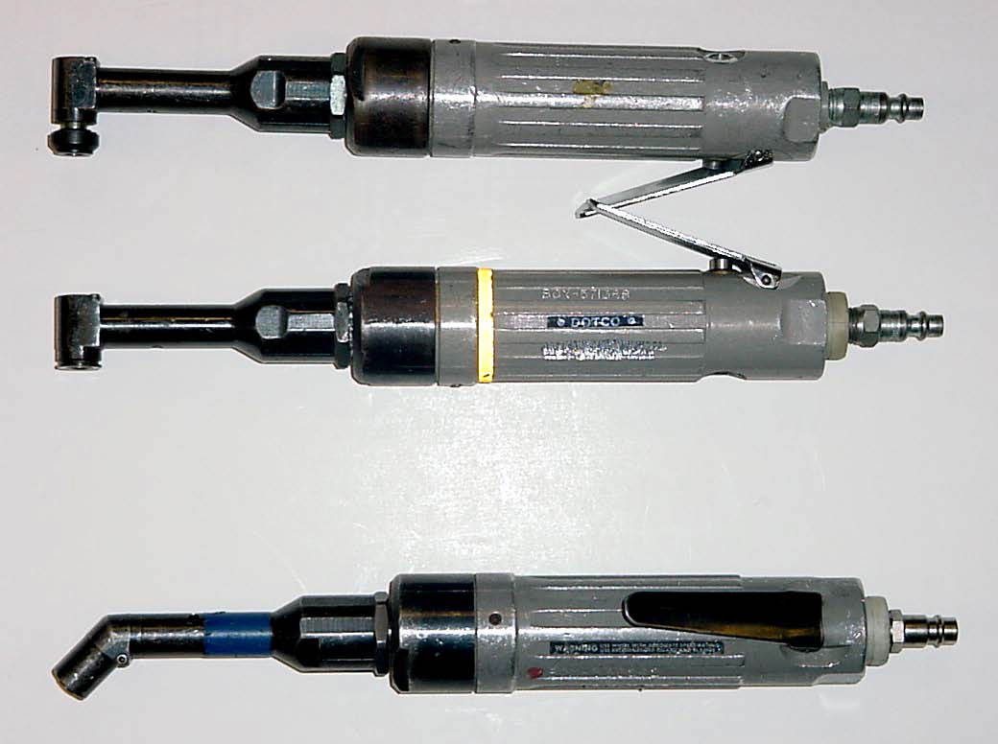
Image courtesy of The Boeing Company

Tool Identification Review
Tool Identification: Rivet Gun
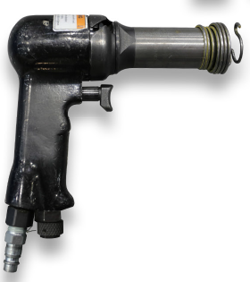
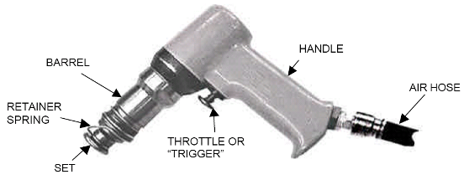
Images courtesy of The Boeing Company

Tool Identification: Cleco Gun
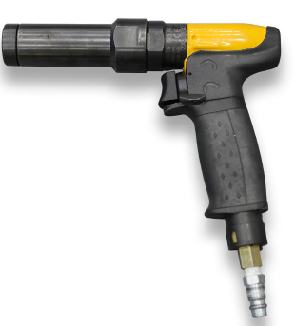

Image courtesy of The Boeing Company

In the illustration, the item on the right is the Cleco gun commonly used in aviation manufacturing nowadays to install power Clecos.

Cleco ID: Power Cleco

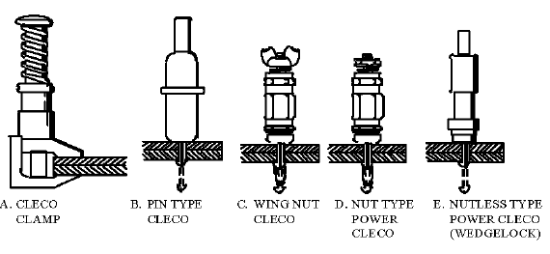
Image courtesy of the Boeing Company

Cleco ID: Spring Cleco (Pin Type)

Image courtesy of The Boeing Company

Tool Identification Review
Tool Identification: Hi-Lok Runner

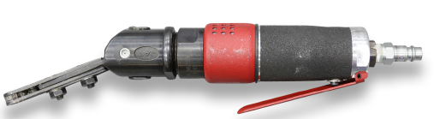

Review of manufacturing skills processes
Review of CorePlus Units
To prepare for the core manufacturing skills assessment, it is recommended that students review their CorePlus booklets and notes from these first year units:
Unit 5 - Precision Measurement
Unit 6 – Fasteners
Unit 7 – Drilling
Unit 9 - Riveting

Drilling
Quality Hole Generation

Hole generation is one of the most crucial steps in the production of an aircraft. In order for fasteners to be installed, holes must first be produced. Aircraft fasteners require accurate holes to meet performance and service goal requirements.

An accurate hole is a hole that meets the location, angularity, dimensions and tolerances of the Engineering Drawing. Accurate hole production will meet product performance requirements and service goals when we create quality holes. In other words, the structure lasts as long as it is supposed to.

Accurate hole production has less rework and therefore lowers the costs of airplanes, making them more desirable to the customer.

We now know WHY we need quality accurate holes in the aircraft; let us take a look at what qualities make up a good hole to install fasteners.

Hole Qualities
- Correct Diameter
- Angularity of 90 degrees
- Parallel Walls
- Scratch-free Bore (smooth surface finish inside hole)
- Proper Edge Margins
- Correct Countersink Depth (if needed)

Drill Guides
Drill guides are important tools that help to produce straight holes that meet angularity requirements.
There are multiple types and sizes of drill guides
- Egg cups drill guides
- Butcher blocks (meat tenderizer) drill guides
- Drill block (tugboats) drill guides

Bushing Identification
Most of the drill guides (with the exception of the butcher block type) have interchangeable bushings to accommodate your various drill sizes. Bushings are identified in the same manner that a drill bit would be identified, (Letter, number or decimal) and need to be sized as close to the drill size as available.

Drill Stops
These are used stop a drill bit from going further once it has drilled down to a pre-determined depth.

Cutting Fluids/Lubricants

Cutting fluids provide three basic functions: (1)chip removal, (2) lubrication, and (3) cooling.

Lubricating action reduces the friction, thus reducing the heat generated.

Cooling action takes away the heat that has been generated.

Cutting fluid is NOT necessarily a “liquid;” it can be available in solid block or paste form. While nontoxic, a minimal amount should be used to avoid unnecessary cleanup on aircraft structure or the work station surfaces.

Clamping of Parts to Be Drilled
Clamping is important:
- Meets any specified clamp-up force requirements
- Aligns parts for drilling
- Continued alignment of holes while drilling and installing permanent fasteners
Always prevent damage to metal skin by using Clecos with nylon caps.
Attend to your clamp-up. Failure to keep a proper clamp-up will result in:
- Part separation
- Burrs & chips between parts
- Misaligned holes
- Mismatched parts
Steps for Hand Drilling
Select proper drill speed and drill bit size and style for material being used.
When hand controlled drilling without a drill template or bushing, a drill stop and hand held drill guide (egg cup or drill block) should be used whenever possible to ensure straight holes that are perpendicular to the work surface.
Always apply protective tape on surfaces that may be damaged due to drilling process.
Place the point of the drill against the work surface before starting the drill motor. Apply medium feed force and then operate the drill motor to rotate the drill bit.

Feed drill bit into the work piece with positive pressure. Use just enough pressure to cut through the material, letting the cutter do the work.

Lubricate drills at least the first and after every 5 holes to reduce drill wear and drilling time.

Maintain hole quality. Be careful not to use too much cutting fluid.

Countersinking
You can go online and view a short video on countersinking:
Countersinking Tips for Flush Rivets
https://www.youtube.com/watch?v=ykK37Ms2UiA

Basic Riveting & Rivet Removal
View a short video that covers the basic process of drilling, riveting, and rivet removal:
Aircraft Sheet Metal: Basic rivet layout, installation, and removal
https://www.youtube.com/watch?v=Pk_fAHoru_o

Flush Riveting
The next video is a classic, but it shows how flush riveting is done and why it’s important to aircraft aerodynamics:

HOW IT WORKS: WWII Aircraft Flush Riveting
https://www.youtube.com/watch?v=IDbTUt3OG9s

NOTE: Just play the first few minutes of the Aircraft Flush Riveting video for our purposes. You can stop the video at 2:35.

Aerospace Riveting
This video provides more useful detail on the aircraft grade riveting process:
Solid Rivet Kit - Aircraft Grade Rivets
https://www.youtube.com/watch?v=sTmuFxEN1Mk

Lock Bolt and Hi-Lok Installation
Use the online resources below to view videos on installation of Hi-Lok fasteners and Huck Bolt fasteners:
Hi Lok install
https://www.youtube.com/watch?v=d_Fx0766n3k

Huck Bolt Fastener
https://www.youtube.com/watch?v=1ae2OBTFNRM

Installation of Torqued Nut & Bolt Fasteners

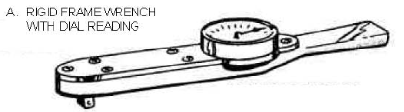
Image courtesy of the Boeing Company

The online instructional video below explains installation of nut & bolt fasteners:
https://www.youtube.com/watch?v=ib5afL3B6ho

Fastener Removal
You will be expected to properly remove all bolts, rivets and fasteners, as if removing defective components. To remove rivets, the head is drilled out carefully using the same diameter drill bit as the original hole size. Then the remainder of the rivet can be popped out of the hole by driving a pin punch from the side where the rivet head was removed. Make sure the drive pin punch is SMALLER diameter than the drill size you used.
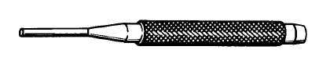
Drive pin punch
Image courtesy of The Boeing Company

Removal of Hex Drive Fasteners & Lock Bolts
- There are many different tools that are useful in the removal of hex-driven fasteners. An Allen wrench is used, as well as one other tool, as shown below.
- There is a tool specifically made to remove certain collars: Hi-Lok Collar Pliers.
- Locking pliers (often referred to as Vise-Grips®) can be used in the same way.

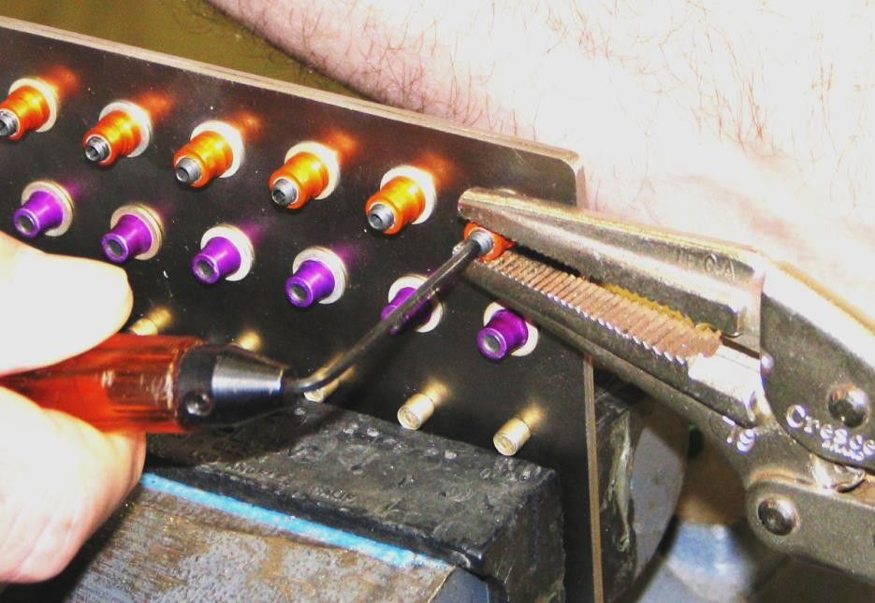
Use of Locking Pliers to remove permanent fastener
Image courtesy of The Boeing Company

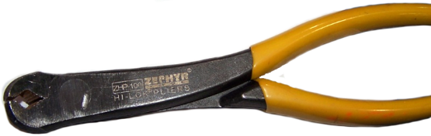
Hi-Lok Collar Pliers
Image courtesy of The Boeing Company

conclusion
Now that you have reviewed basic manufacturing concepts and skills that were covered in the previous year’s CorePlus, you will have opportunities to practice those skills in a series of hands-on activities.

