

Unit 11: Practice and Assessment
Lesson 1: Core Manufacturing Skills Review
Lesson 2: Skills Practice Activities
Lesson 3: Assessment of Core Manufacturing Skills

Lesson Plan Description
This is the first lesson in this unit dedicated to the review, practice and assessment of basic manufacturing skills. This lesson is a review of those skills.

In addressing ergonomic and efficiency issues, stands such as the Bosch stand, (see below for an illustration) are commonly used in training. Available drawings/plans to build Bosch stands have been generously provided by Pacific Integrated Handling.

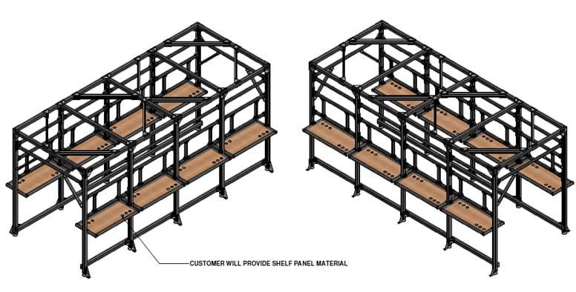
Copyright use permission Pacific Integrated Handling, May 2016.

Consider making these stands to create a manufacturing setting in the classroom. Students may encounter these type of stands when training at large manufacturing companies. The complete plans may be found in Lesson 1 Addendum.

Lesson Learning Objectives
Upon completion of this lesson, the student will be able to:
- Recall skills and knowledge relating to drilling for quality, deburring, and countersinking.
- Recall skills and knowledge relating to fastener installation, specifically rivets, Hi-Loks, lockbolts, and standard nuts & bolts.

Lesson Modules:
There are no separate modules in Lesson 1.

Materials & Resources:
- PowerPoint Presentation
- Addendum
  - Knowledge Assessment Quiz
  - Build: Bosch Stand Plans for Practicing Manufacturing Skills
- Student Booklet
- Videos:
- https://www.youtube.com/watch?v=ykK37Ms2UiA
(8:34) Countersinking Tips for Flush Rivets
- https://www.youtube.com/watch?v=Pk_fAHoru_o
(6:50) Aircraft Sheet Metal: Basic rivet layout, installation, and removal
- https://www.youtube.com/watch?v=IDbTUt3OG9s
(10:35) HOW IT WORKS: WWII Aircraft Flush Riveting
- https://www.youtube.com/watch?v=sTmuFxEN1Mk
(5:36) Solid Rivet Kit - Aircraft Grade Rivets
- https://www.youtube.com/watch?v=d_Fx0766n3k
(0:20) Hi-Lok install
- https://www.youtube.com/watch?v=1ae2OBTFNRM
(0:12) Huck Bolt Fastener
- https://www.youtube.com/watch?v=ib5afL3B6ho
(0:16) Installing Bolt Rivet Nut

Equipment and Supplies:
- No extra equipment and supplies are required for this lesson.
- If instructor wishes to provide a shop demonstration, then the following tools will be needed:
  - Power hand drill
  - Deburring tool
  - Countersink
  - Rivet gun
  - Bucking bar
  - Drive pin punch
  - Various drill bits
  - If building the Bosch stand, a list of equipment will resemble the following:
Material purchase-
    - 45 x 90 Bosch profile frame 9 sticks $1,767.78
    - 45 x 45 Bosch profile frame 9 sticks $726.93
    - (138) 45 x 90 gussets $746.58
    - (16) 90 x 90 gussets $181.76
    - (12) 45 series corner join plates $131.88
    - (14) 45 series “T” join plates $205.52
    - (4) 90 series corner join plates $82.32
_________
Total $3,842.77
There is approximately another $600 in hardware.

Assessments:
- Checks for Understanding (Included in Lesson Plan & PowerPoint presentation)
- Knowledge Assessment Lesson Quiz (included in Lesson 1 addendum)

Instructor Notes:
Lesson Delivery – Lesson 1: Core Manufacturing Skills Review
Unit 11: Practice and Assessment

Lecture (in conjunction with the PowerPoint):
As the title slide is shown, instructor should discuss:
What’s in it for me (WIIFM)? Why should I learn this?
What this unit is all about?
How this unit fits into the big picture of aerospace training?

INTRODUCTION

Course Information

Lesson Objectives
(Read the objectives from the screen and discuss with the students.)
TOOL IDENTIFICATION REVIEW
Introduction: Core Manufacturing Skills Review
To enter a career in aviation manufacturing, you must show competency in the basic core manufacturing skills used by entry-level aircraft assemblers. All the knowledge and skills you’ve learned in the CorePlus curriculum is valuable, but the basic skills of drilling, countersinking, deburring, and fastener installation are critical.

One of the first things that any employer will do is test you in these skills. Being familiar with the skills is not enough. Showing competency is a minimum expectation, expertise in these skills is what your future employer will really want to see.

This unit will provide opportunities to further practice your core manufacturing skills that you originally learned during the first year units of CorePlus.

Tool Identification: Pistol Grip Drill Motor

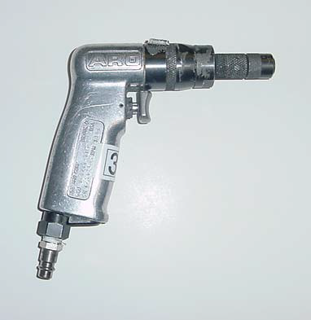
Image courtesy of The Boeing Company

Tool Identification: 90 Degree Drill Motor
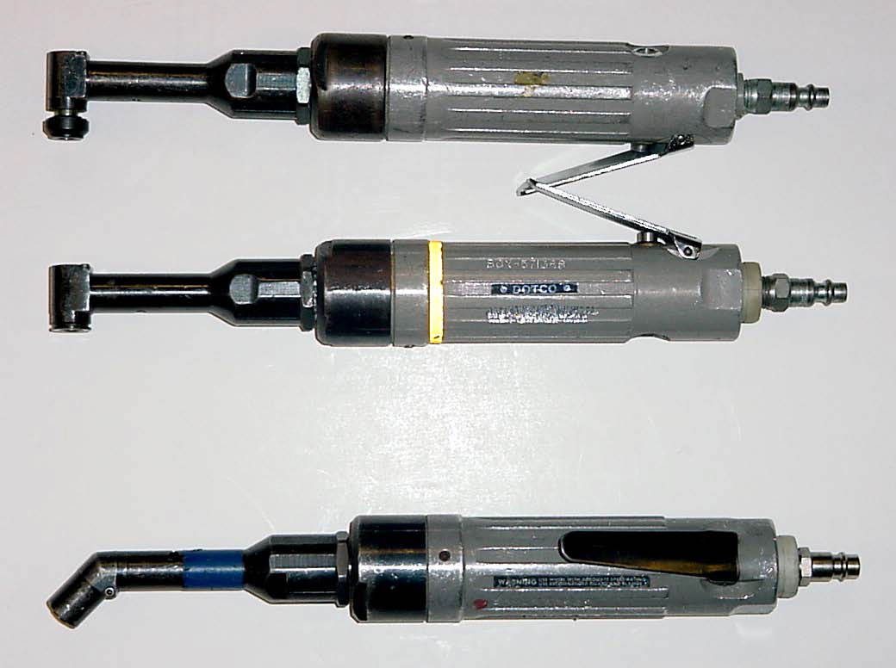
Image courtesy of The Boeing Company

Tool Identification: Rivet Gun
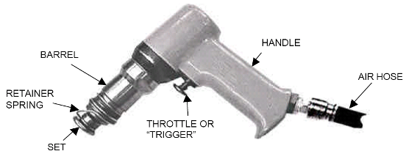
Image courtesy of The Boeing Company

Tool Identification: Cleco® Gun

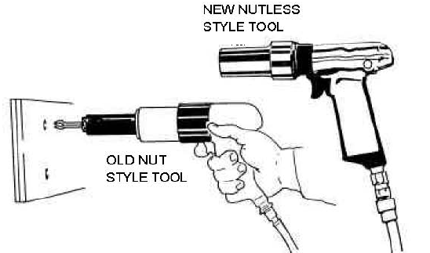

Image courtesy of The Boeing Company

In the illustration, the item on the right is the Cleco® gun commonly used in aviation manufacturing nowadays.

Cleco® ID: Power Cleco®

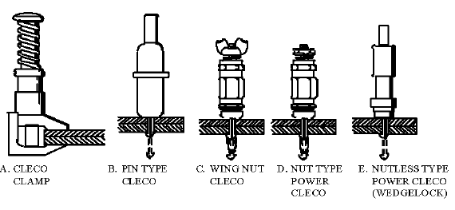
Image courtesy of The Boeing Company

In the illustration, Item E is an example of a Power Cleco®.

Cleco® ID: Spring Cleco®

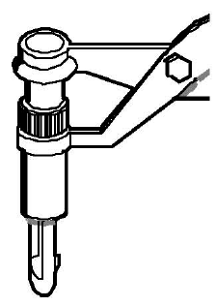
Image courtesy of The Boeing Company

Cleco® ID: Pin Type Cleco®

Image courtesy of The Boeing Company

In the illustration, Item B is known as a Pin Cleco® or Draw/Power Cleco®.

REVIEW OF MANUFACTURING SKILLS PROCESSES

Review of CorePlus Units
To prepare for the core manufacturing skills assessment, it is recommended that students review their CorePlus booklets and notes from these first year units:
- Unit 5 - Precision Measurement
- Unit 6 – Fasteners
- Unit 7 – Drilling
- Unit 9 - Riveting

If time allows, the instructor may show the CorePlus presentation slides from those units as a class review of the concepts and skills involved.

Countersinking
The link below will allow you to view a short video on countersinking:

Video: Countersinking Tips for Flush Rivets (8:34)
https://www.youtube.com/watch?v=ykK37Ms2UiA

Basic Riveting & Removal 1
The link below will allow you to view a short video that covers the basic process of drilling, riveting, and rivet removal.

Video: Aircraft Sheet Metal: Basic Rivet Layout, Installation, and Removal (6:50)
https://www.youtube.com/watch?v=Pk_fAHoru_o

Basic Riveting & Removal 2
The next video is a classic, but it shows how flush riveting is done and why it’s important to aircraft aerodynamics:

Video: HOW IT WORKS: WWII Aircraft Flush Riveting (10:35)
https://www.youtube.com/watch?v=IDbTUt3OG9s

Instructor note: Just play the first few minutes of the Aircraft Flush Riveting video. Stop the video at 2:35. If the video begins to explain the “Double Dimple Method,” you’ve gone too far.

Aerospace Riveting
This video provides more useful detail on the aircraft grade riveting process:

Solid Rivet Kit - Aircraft Grade Rivets (5:36)
https://www.youtube.com/watch?v=sTmuFxEN1Mk

Lock Bolt and Hi-Lok Installation
Click on the links below to view videos on installation of Hi-Lok fasteners and Huck Bolt fasteners:
Video: Hi-Lok install (:20)
https://www.youtube.com/watch?v=d_Fx0766n3k
Video: Huck Bolt Fastener (:12)
https://www.youtube.com/watch?v=1ae2OBTFNRM

Installation of Torqued Nut and Bolt Fasteners

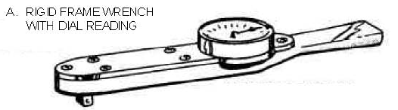
Image courtesy of The Boeing Company

The link below allows you to view an instructional video on installation of nut & bolt fasteners:
Video: Installing Bolt Rivet Nut (:16)
https://www.youtube.com/watch?v=ib5afL3B6ho

Fastener Removal
You will be expected to properly remove all bolts, rivets and fasteners, as if removing defective components. To remove rivets, the head is drilled out carefully using the same diameter drill bit as the original hole size. Then the remainder of the rivet can be popped out of the hole by driving a pin punch from the side where the rivet head was removed. Make sure the drive pin punch is SMALLER diameter than the drill size you used.

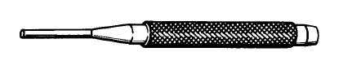
Drive pin punch
Image courtesy of The Boeing Company

Fastener Removal: Hex Drive and Lock Bolts
- There are many different tools that are useful in the removal of hex-driven fasteners. For example, an Allen wrench may be used and shown below is another tool, the Locking Pliers.
- There is a tool specifically made to remove certain collars: Hi-Lok Collar Pliers.
- Locking pliers (often referred to as Vise-Grips®) can be used in the same way.

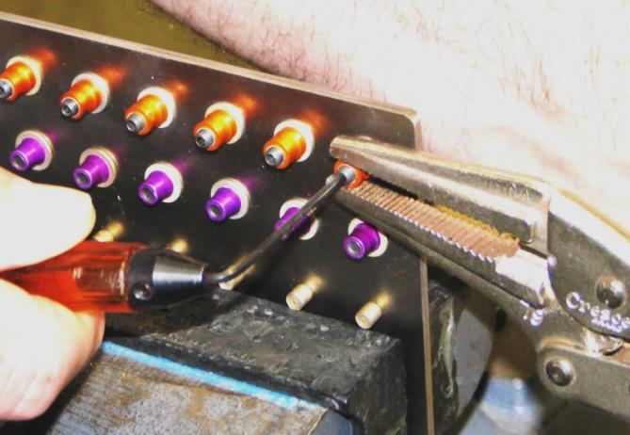
Use of Locking Pliers to remove permanent fastener
Image courtesy of The Boeing Company

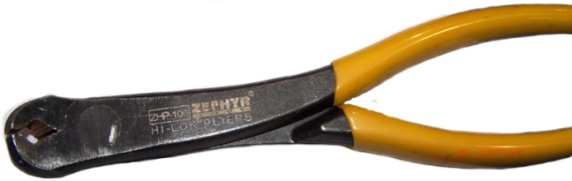
Hi-Lok Collar Pliers
Image courtesy of The Boeing Company

Conclusion
Now that we have reviewed basic manufacturing concepts and skills that were covered in the previous year’s CorePlus, you will have opportunities to practice those skills in a series of hands-on activities.

A short written quiz will be given first, which will assess your recall of concepts reviewed in this lesson.

Acknowledgements
Aerospace Joint Apprenticeship Committee (AJAC), American Society of Metals (ASM), the Boeing Company, National STEM Consortium (NSC), Washington Manufacturing Advanced Training Institute (WMATI)

About These Materials

Copyright
© 2015 by Washington Manufacturing Advanced Training Institute (WMATI)
The CorePlus: Manufacturing Skills Curriculum is a collaboration among Boeing, and WMATI.

License
Unless otherwise specified, this work is licensed under a Creative Commons Attribution-ShareAlike 4.0 International License.

Attribution
To attribute this course reference Washington Manufacturing Advanced Training Institute (WMATI).

Citation
To cite this course use the following citation example:
Washington Manufacturing Advanced Training Institute (WMATI). CorePlus Manufacturing Skills Curriculum: Precision Measurement Course. [URL if applicable.] CorePlus, 2015.

Disclaimer
This workforce solution was built from open license materials from many sources. There are no guarantees, warrantees, or assurances of any kind, express or implied, with respect to such information, including any information on linked sites and including, but not limited to, accuracy of the information or its completeness, timeliness, usefulness, adequacy, continued availability, or ownership.

