2014 Plan for the League City Church of Christ
Charlie Wheeler – January 19, 2014
Slide 1 | 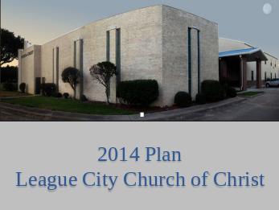 | As we began preparing for the message today, the message that John presented in Revelation came to mind as the Lord addressed the challenges and opportunities that the seven churches of Asia faced during the first century. So what do those issues have to do with us as we begin 2014?
Slide 2 | 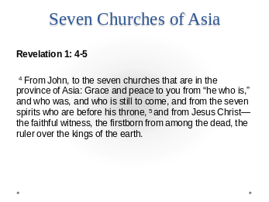 | We believe that the same issues that our Lord was speaking to when he addressed these seven churches are true today. In all that we do we need to keep in mind that there is someone watching and just as our Lord was calling to these churches, he will one day call to us. What will he say about the church at League City Texas?  Revelation 1: 4-5  ⁴ From John, to the seven churches that are in the province of Asia: Grace and peace to you from “he who is,” and who was, and who is still to come, and from the seven spirits who are before his throne, ⁵ and from Jesus Christ—the faithful witness, the firstborn from among the dead, the ruler over the kings of the earth.
Slide 3 | 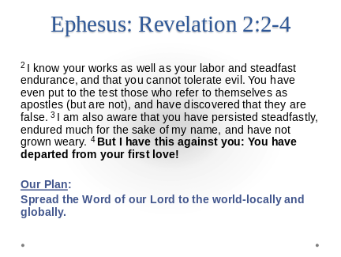 | Ephesus: Revelation 2:2-4  ² I know your works as well as your labor and steadfast endurance, and that you cannot tolerate evil. You have even put to the test those who refer to themselves as apostles (but are not), and have discovered that they are false. ³ I am also aware that you have persisted steadfastly, endured much for the sake of my name, and have not grown weary. ⁴ But I have this against you: You have departed from your first love!  Our first love is to spread the word of our Lord to the world. We want to keep that foremost in our plans for League City. We may do many things during 2014 but let us remember our first objective is to spread that message to all we come in contact with.
Slide 4 | 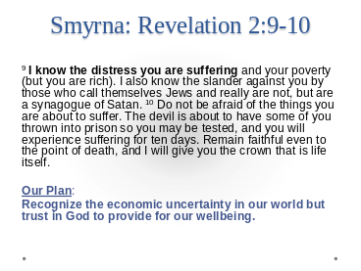 | Smyrna: Revelation 2:8  ⁹ I know the distress you are suffering and your poverty (but you are rich). I also know the slander against you by those who call themselves Jews and really are not, but are a synagogue of Satan. ¹⁰ Do not be afraid of the things you are about to suffer. The devil is about to have some of you thrown into prison so you may be tested, and you will experience suffering for ten days. Remain faithful even to the point of death, and I will give you the crown that is life itself.  We all can recognize the economic uncertainty in our world but we trust in God to provide for our wellbeing.
Slide 5 | 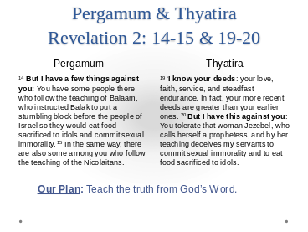 | Pergamum: Revelation 2:12  ¹³ ‘I know where you live—where Satan’s throne is. Yet you continue to cling to my name and you have not denied your faith in me, even in the days of Antipas, my faithful witness, who was killed in your city where Satan lives. ¹⁴ But I have a few things against you: You have some people there who follow the teaching of Balaam, who instructed Balak to put a stumbling block before the people of Israel so they would eat food sacrificed to idols and commit sexual immorality. ¹⁵ In the same way, there are also some among you who follow the teaching of the Nicolaitans.  Thyatira- Revelation 2:18  ¹⁹ ‘I know your deeds: your love, faith, service, and steadfast endurance. In fact, your more recent deeds are greater than your earlier ones. ²⁰ But I have this against you: You tolerate that woman Jezebel, who calls herself a prophetess, and by her teaching deceives my servants to commit sexual immorality and to eat food sacrificed to idols.  We have grouped these two messages together because they represent problems of error and allowing error to abide in the church. Our goal and desire is always to teach the truth from God’s Word. If we are to please God, we cannot allow sin to abide in our congregation.
Slide 6 | 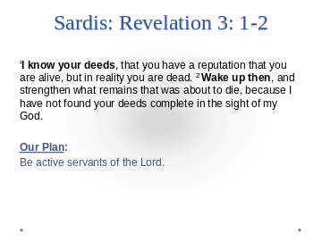 | Sardis: Revelation 3:1-2  I know your deeds, that you have a reputation that you are alive, but in reality you are dead. ² Wake up then, and strengthen what remains that was about to die, because I have not found your deeds complete in the sight of my God.  We don’t want to play church we desire to be active servants of the Lord. The things that we do should impact those around us inside and outside this congregation.
Slide 7 | 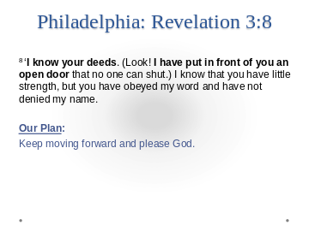 | Philadelphia: Revelation 3:8  ⁸ ‘I know your deeds. (Look! I have put in front of you an open door that no one can shut.) I know that you have little strength, but you have obeyed my word and have not denied my name.  The power to succeed does not lie in our hands… God is in control and through him we can accomplish much. We want to strive to keep moving forward in all that we do to please him.
Slide 8 | 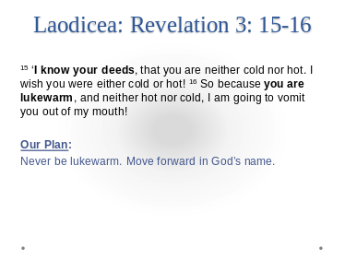 | Laodicea: Revelation 3:14  ¹⁵ ‘I know your deeds, that you are neither cold nor hot. I wish you were either cold or hot! ¹⁶ So because you are lukewarm, and neither hot nor cold, I am going to vomit you out of my mouth!  This is one of our greatest worries… We don’t want to be part of a lukewarm body. If we are not moving forward then we are moving back. This is our challenge for 2014 let us move forward in God’s name.

Slide 9 | 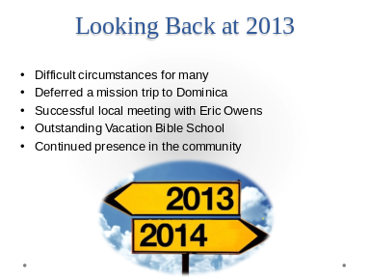 | As we began to plan for this year our first step was to recognize the things that were within our control and the things that were out of our control.  We had a very successful 2013 year in spite of some difficult circumstances over not only last year but even the prior years. The elders understood that many in this congregation found themselves searching for employment and as a result many of us had to cut back on our giving during the past couple of years.  For the first time in many years we did not send a team out on a mission trip to Dominica. We were still able to conduct a very successful local meeting and the congregation rallied around this effort and participated in ways that we have not seen in quite some time. For this effort, we as elders are very pleased.  Your efforts continued during the summer with an outstanding Vacation Bible School and Summer Bible reading Program. This activity has been well received in the community and we know that we have families attending here now because of this outreach.
Slide 10 |  | As we move into 2014 we are beginning to sense an improvement in the economic environment and are optimistic that our circumstances will continue to progress in a positive way.  Are you ready??? Here it comes!
Slide 11 | 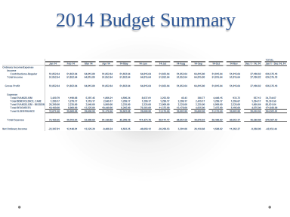 | This is the summary of our 2014 budget….. If you are an accountant, I bet you are on the edge of your pew! If you are not an accountant you probably just yawned…  We have a spreadsheet with numbers representing our income from our contributions and then we have some numbers representing our expenses from our bills.  In a perfect world those would equal each other and everything would be dandy. Pretty exciting stuff huh?
Slide 12 | 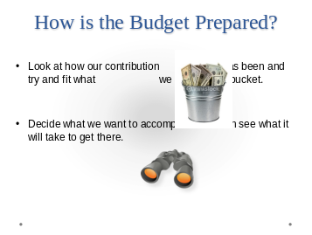 | When budgeting for our activities, there are a couple of ways that this can be accomplished.  We can look at how our contribution has been historically and then try and fit what we do into that bucket. This is often the approach that is taken.  Another way to approach the budget is to decide what we want to accomplish and then see what it will take to get there.  This is the approach that we have chosen to take.
Slide 13 | 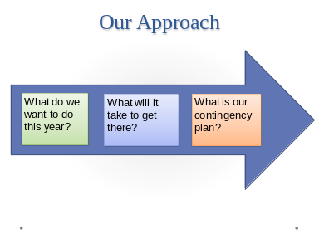 | Our reasoning was to involve the Deacons in the process and let them tell us what they wanted to do. If the numbers seemed reasonable then that is what we would do. Ultimately we are only going to be able to do what we can afford to do and that will determine how much of our goals are accomplished in 2014. In other words:  - What do we went to do this year?  - What will it take to get there?  - What is our contingency plan?
Slide 14 | 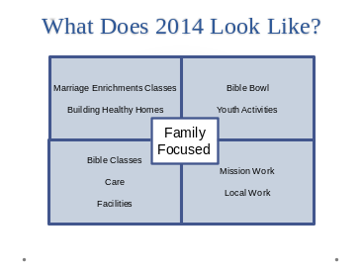 | What does 2014 look like?  If I were to come up with a theme for this year, I would probably describe it as “Family Focused”  We have been looking for quite some time now at how we can help to strengthen the family and this seems to be of concern to all of us. Many of the activities we will be involved with have this focus to them.  Marriage Enrichment classes are taking place at this time and we hope to continue with additional classes this year. These take place outside of our normal meeting times and are being led by Joe and Connie Higgenbotham. We have also budgeted for training of additional facilitators to assist in this area.  (CONTINUE on NEXT PAGE)  Building Healthy Homes with Phil Sanders will be this year’s meeting in the first week of March. Please continue to pray for this and make plans to be here for this event.  Bible Bowl is an activity that falls under our youth activities but has morphed over the years into more of a family activity. This is pure bible study and we are thankful to the Cuttrells, Vetitos, Johnsons, along with many other families that have continued to support and develop this opportunity for the congregation to grow in knowledge of God’s word.  Youth Activities continue to be one of the more effective ways to reach into our community and we continue to support the camps, retreats, and service activities that are part of our 2014 goals.  Vacation Bible School has been one of the more successful efforts the past few years in not only reaching out to our community but also allowing an inclusive atmosphere within the congregation. We are thankful for the efforts that Pat Marrie and a team that he has worked with to continue improving our VBS. They have a five year plan in place and are well on their way to meeting their plans for a sustaining VBS program. Our challenge to Pat has been to continue to bring more people into the program so that this is a congregational effort that will be known in League City. Let’s not forgot the success of the Summer Reading Program that involves both children and adults in our congregation.  Mission work from League City continues to be a focus this year. Our missionaries are Shelly Bryant in Singapore and China, Nick Gill in Belarus, Kell George in Dominica, Cornelius George in Monserrat. All of these activities are taking place outside of the US. The elders have discussed and feel like there are some opportunities within the states that may be of interest to the members now and in the future. We have decided to begin assisting Josh Austin in his work with Native Americans in Arizona. Our hope is that this relationship will continue to grow and provide opportunities for the congregation to experience mission work within the US. When you have a chance, stop by the bulletin board and look at the photos of thee missionaries and the reports they have sent us.  Our work with the church in Salsibury Dominica has been in a period of transition for the last year or so and Brother Kell George is trying to strengthen the congregation there. Our plans are to go down in May to evaluate and encourage the brothers and sisters in Salisbury. Kim Wheeler will be organizing a Ladies day for those ladies of the congregation similar to the ones we have here in League City.  In July Ralph will be taking a team to Salisbury to work in conjunction with the meeting being planned by brother Kell. It has been a while since a campaign took place in Salisbury and we are hoping this will be an encouragement to them.  Many of you are aware of the college students from League City that are planning mission trips during their spring breaks.  The Parkers, will once again be spending time in Singapore during the summer assisting with the work there.  Many of you continue to visit the nursing homes during the week as well as providing communion praying and singing and encouraging.  These are all activities that reach out to the world locally and abroad.  We continue to have great Bible classes for children, teenagers, adults, moms, and from time to time special classes. Care of both members and Benevolence to those in need must be addressed. All of this takes place in excellent facilities that must be maintained.  It looks like 2014 is going to be a busy but productive year.
Slide 15 | 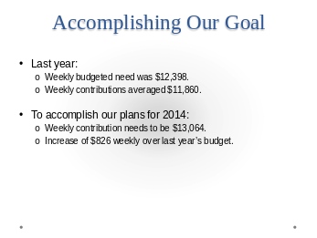 | So what will it take for us to accomplish our goals for this year? For the past few years the elders have had a desire to include as much of the expected expenses in the budget as possible and to minimize the need for special contributions. We are continuing to work towards that with this year’s budget.  The weekly budgeted need during 2013 was $12,398 and this congregation responded well averaging $11,860 per week. We feel that this was exceptional given the economic difficulties that many faced during this period.  To accomplish our plans this year the weekly contribution needs to be $13,064. This is an $826 weekly increase over last year’s budget.  The elders feel that this is an attainable goal for two reasons.  The ground work that this congregation has laid over the past few years has positioned League City for growth. You are talking to your friends and neighbors about the good things that are happening at League City church of Christ. We trust that this will continue and we will be able to achieve our desires to continue spreading God’s word and be pleasing to him.  Secondly we are confident that this plan will take place because this congregation has always responded positively when a challenge is placed before them. You are a people that strive to serve God and we know you will continue to rise to this challenge.
Slide 16 | 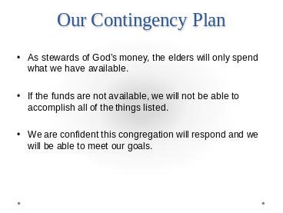 | What is our Contingency Plan?  A budget is a tool to help you plan. These are the things that we would like to accomplish this year. As stewards of God’s money, the elders will only spend what we have available.  If the funds are not available, obviously we will not be able to accomplish all of the things the deacons have said they would like to do this year.  We are confident this congregation will respond and we will be able to meet our goals.
Slide 17 | 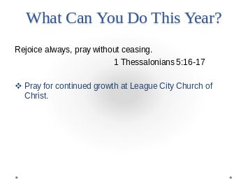 | What can you do to make this happen?  1 Thessalonians 5:16-17 tells us to Rejoice always and Pray without ceasing.  This is certainly applicable for us today. Pray that we will be able to continue as a steadfast congregation of the Lord’s people that continues to grow. Rejoice in the blessing that we have as loving caring brothers and sisters in Christ here at League City.
Slide 18 | 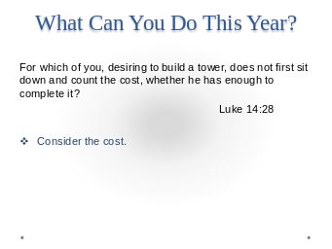 | Luke 14: 28 tells us For which one of you desiring to build a tower does not first sit down and count the cost?  I would encourage each of you as a family to sit down together and reflect on your circumstances. If you see that you can increase your giving then do so if not then “Rejoice Always”.
Slide 19 | 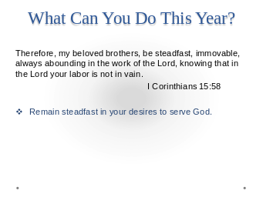 | 1 Corinthians 15:58 “Therefore my beloved brothers, be steadfast, immovable always abounding in the work of the Lord, knowing that in the Lord, your labor is not in vain”.  Remain steadfast in your desires to serve God. We want each of you to be involved … there are plenty of opportunities here at League City but most of all we want you to serve God in all you do.
Slide 20 | 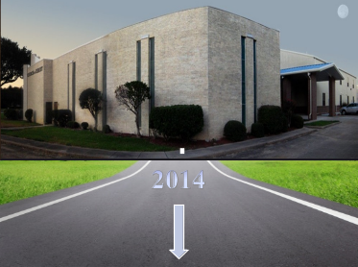 | If you have questions or want more detail on the plans we have for this year or questions in general, contact one of the elders and we will be happy to talk with you.  We never want to leave an assembly without offering an opportunity to serve those in attendance. If there is a need that we can assist with please come as we stand and sing.

